**INSTAGRAM USER ANALYTICS**

**1)PROJECT DESCRIPTION:** IN THIS PROJECT I’VE GOTTEN SOME INSIGHTS FROM THE INSTAGRAM DATABASE AND HAD ANSWERED THE FOLLOWING QUESTIONS FROM MARKETING AND INVESTOR METRICS BACKGROUND.

**MARKETING:**

Task 1: Find the 5 oldest users of the Instagram from the database provided

Task 2: Find the users who have never posted a single photo on Instagram

Task 3: Identify the winner of the contest and provide their details to the team

Task 4: Identify and suggest the top 5 most commonly used hashtags on the platform

Task 5: Provide the day of week on which most users register to instagram

**INVESTOR METRICS:**

Task 6: Provide posts made by an average user

Task 7: Provide fake users

**2)APPROACH:**

TASK 1: In task 1 I’ve sorted the table through the column created_at which states the date account was created on and then set limit to 5 to get 5 oldest users of instagram.

TASK 2: In this task I’ve joined photos table and users table using full outer join and groupby users in the table to count no. of images posted by per user and then displayed the user details from user table of the users who have never posted a single photo on instagram.

TASK 3:In this task I’ve used the likes table and groupby using photo_id to count no. of likes each photo has got and then sorted the table in descending order and set limit to 1 and from this I got the photo_id of the photo with most likes and then used that id to get the user_id of the user to whom that photo belongs and after that provide the details of the user from users table

TASK 4: In this task I’ve used the photo_tags table and groupby tag_id and counted the no. of photos on which this particular tag was used and then sorted the table in descending order and then set the limit to 5 to get 5 most commonly used hashtags and then printed the details of those 5 hashtags from tags table

TASK 5:

TASK 6: In this task I’ve used photos table and groupby the user_id to count no. of photos by every user per day and counted the no. of photos and no. of users from photos and users table respectively

TASK 7: In this task I’ve used the likes table and groupby user_id and then counted the no. of photos particular user has liked and then printed the user_ids of the users who have photo_liked_count of 257, as there are total 257 photos and then provided the details of those dummy users from the users table

**3)TECH-STACK USED : pgAdmin4 (for SQL Tasks), MSWord .**

**4)INSIGHTS:**

**TASK 1:**

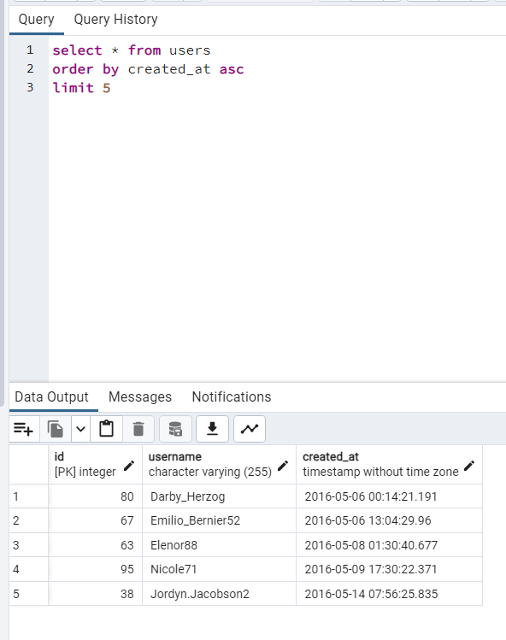

**2)TASK 2:** 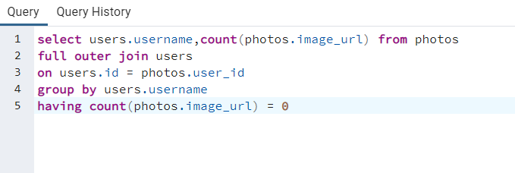

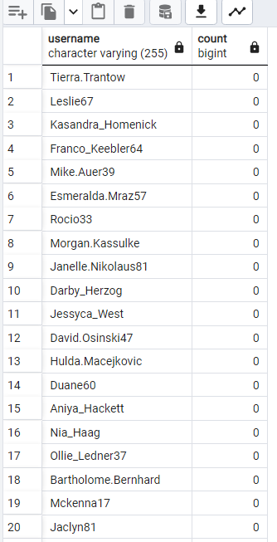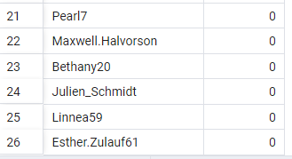

**3)TASK 3:** 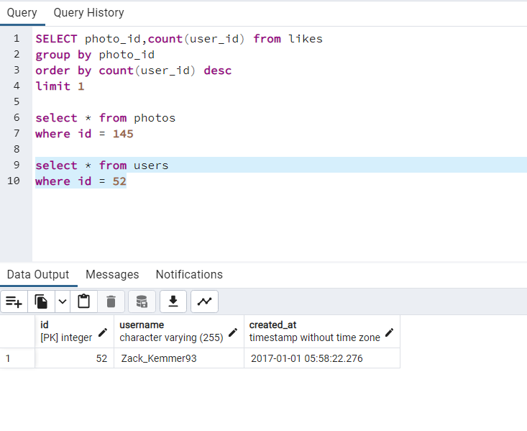

**4)TASK 4:**

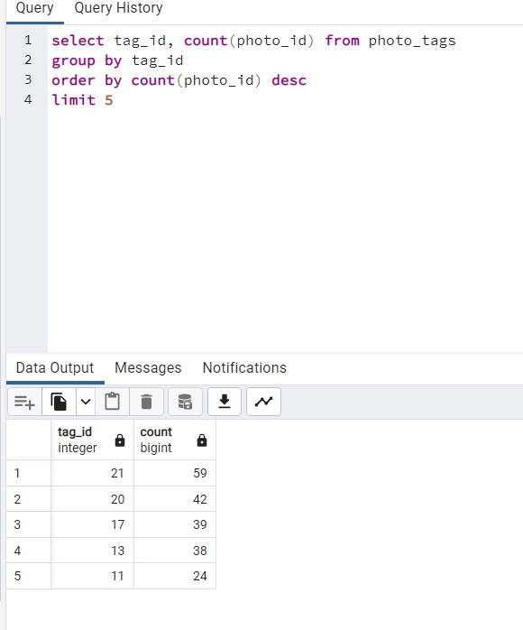

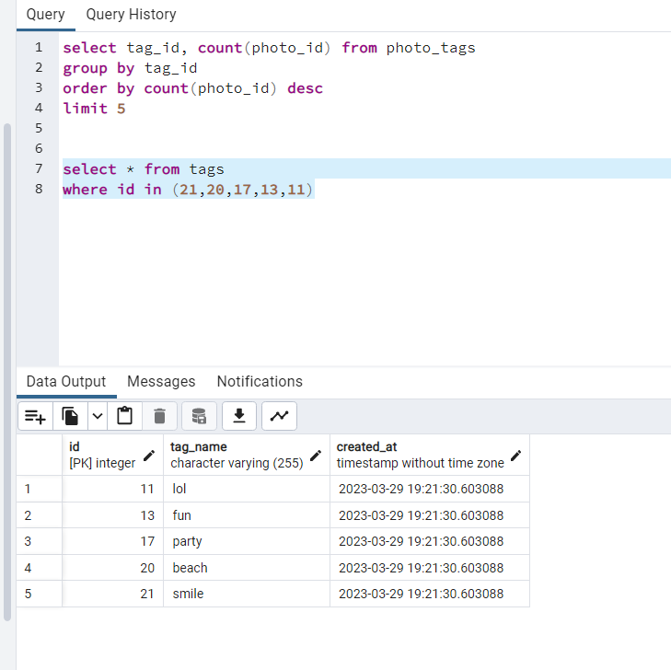

**5)TASK 5: the best day to launch ads is thrusday**

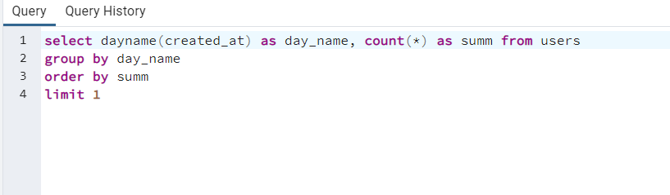

**6)TASK 6: from the insights we’ve got I can say that an average user posts around 1 to 5 photos daily and there are total 100 users and total 257 photos**

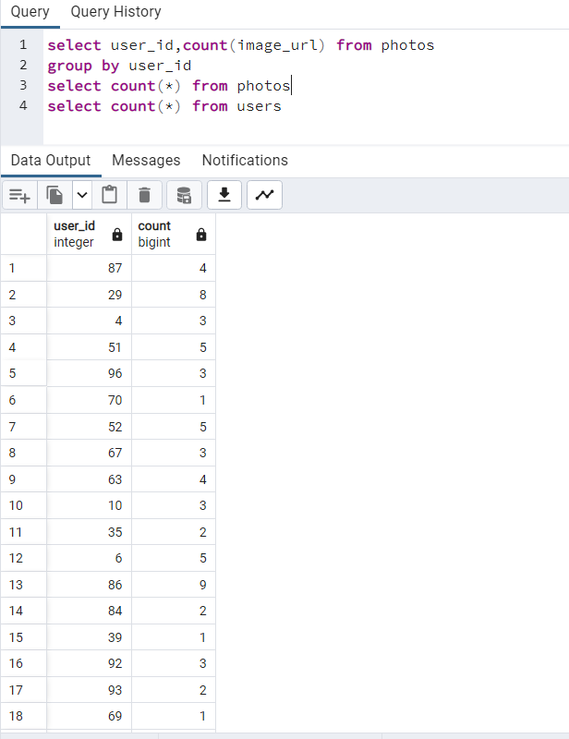

**7)TASK 7:**

**DUMMY USERS ON INSTAGRAM**

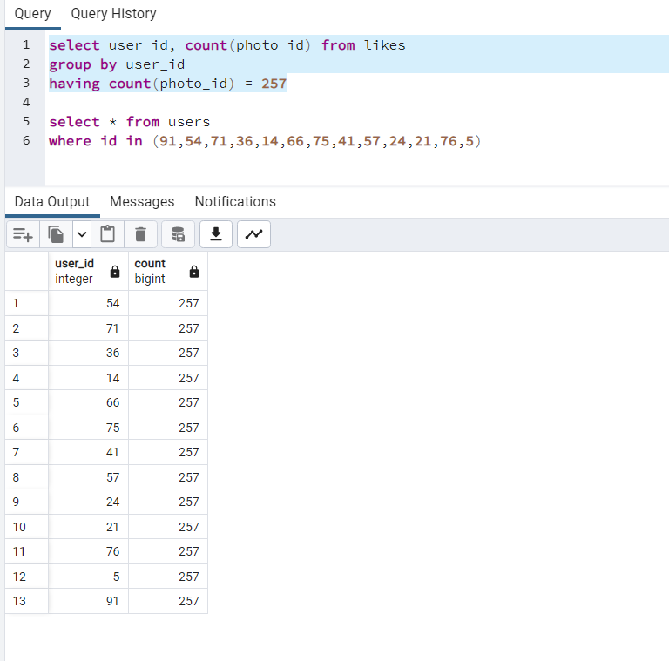

**DETAILS OF THE DUMMY USERS :**

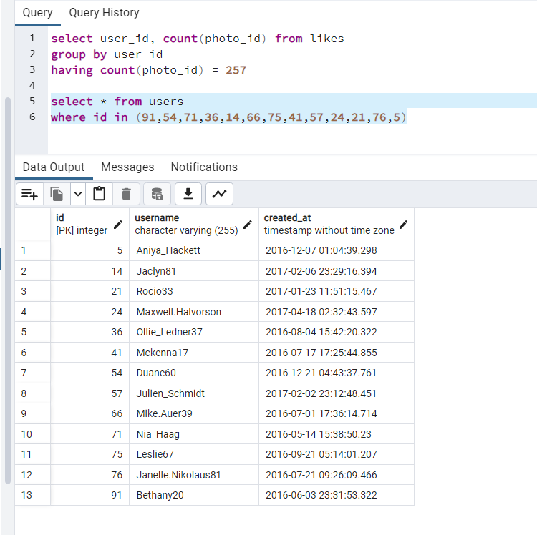

**5)RESULTS:**

**From these task I’ve learnt basics of sql and I’ve developed a thinking which will help me to deal with sql databases in future**

**PLAGARISM REPORT OF THIS WORD DOCUMENT**

